Maths Sample Paper

04


 ⁺⁹¹⁻⁷⁰⁰⁰⁸⁷⁹⁹⁴⁵



9th Class
CBSE
Chemistry By : Er. Jitendra Gupta sir
Topic : 1. Number system 2. Polynomials 3. Coordinate Geometry
4. Linear equations 5. Lines and angles 6. Triangles 7. Quadrilaterals
M.M: 80 Date: M.T.: 180 Min.

General Instructions-
- Every Question is Compulsory.
- Keep Answer copy Neat and Clean.
- Use of Calculator, slide rule, Graph paper & Trigonometric Tables is Not Permitted.

Section-'A' Each Quetions-1 Mark

 | Section A
1 | Simplify:${\left(-\frac{1}{27}\right)}^{\frac{-2}{3}}$  a) $\frac{1}{9}$  b) 9  c) 27  d) - $\frac{1}{9}$ | [1]
2 | The value of$\sqrt{20}×\sqrt{5}$ is  a) $4\sqrt{5}$  b) 10  c) $20\sqrt{5}$  d) $2\sqrt{5}$ | [1]
3 | The simplest form of$0.5\overline{7}$ is  a) $\frac{26}{45}$  b) $\frac{57}{100}$  c) $\frac{57}{99}$  d) $\frac{57}{90}$ | [1]
4 | 75$×$ 75 + 2 $×$ 75 $×$ 25 + 25 $×$ 25 is equal to  a) 3750  b) 7500  c) 10000  d) 6250 | [1]
5 | (x + 1) is a factor of the polynomial  a) x$​^{4}$ + 3x $​^{3}$ + 3x $​^{2}$ + x + 1  b) x$​^{3}$ +x $​^{2}$ - x + 1  c) x$​^{4}$ + x $​^{3}$ + x $​^{2}$ + 1  d) x$​^{3}$ + x $​^{2}$ + x + 1 | [1]
6 | If x$​^{2}$ + kx + 6 = (x + 2)(x + 3), for all x, then the value of k is  a) 1  b) 3  c) - 1  d) 5 | [1]
7 | Point ( - 7, 0) lies  a) on the negative direction of the x - axis  b) in the IV quadrant  c) on the negative direction of the y - axis  d) in the III quadrant | [1]
8 | The abscissa of any point on the x - axis is  a) 0  b) 1  c) x  d) – 1 | [1]
9 | The point whose ordinate is 3 and which lies on the y - axis is  a) (3,3)  b) (0,3)  c) (1,3)  d) (3,0) | [1]
10 | How many linear equations in ‘x’ and ‘y’ can be satisfied by x = 1, y = 2?  a) Three  b) Infinitely many  c) Two  d) Only one | [1]
11 | Which of the following points lie on the line y = 3x – 4?  a) (3, 9)  b) (5, 15)  c) (2, 2)  d) (4, 12) | [1]
12 | The graph of y = 4x will  a) on positive axis  b) intersect x - axis  c) intersect y - axis  d) pass through the origin | [1]
13 | If a transversal intersects two parallel lines, then which of the following alternatives is not true?  a) Each pair of corresponding angles is equal.  b) Each pair of co - interior angles is supplementary.  c) Each pair of co - interior angles is complementary.  d) Each pair of alternate interior angles is equal. | [1]
14 | An exterior angle of a triangle is$80^{0}$ and the interior opposite angles are in the ratio 1 : 3. Measure of each inte4rior opposite angle is :  a) 30$​^{0}$ , 90 $​^{0}$  b) 30$​^{0}$ , 60 $​^{0}$  c) 40$​^{0}$ , 120 $​^{0}$  d) 20$​^{0}$ , 60 $​^{0}$ | [1]
15 | In the given figure (not drawn to scale), find the value of$∠$ DOC.  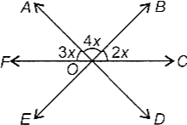  a) 30°  b) 60°  c) 75°  d) 50° | [1]
16 | In an isosceles triangle, if the vertex angle is twice the sum of the base angles, then the measure of vertex angle of the triangle is  a) 120°  b) 110°  c) 100°  d) 130° | [1]
17 | In a$△$ ABC,if $∠$ A = 60°, $∠$ B = 80° and the bisectors of $∠$ B and $∠$ C meet at O, the $∠$ BOC =  a) 30°  b) 120°  c) 150°  d) 60° | [1]
18 | In$ΔABCandΔDEF$ its is given that $∠B=∠Eand∠C=∠F$ in order that $ΔABC≅ΔDEF$ we must have  a) AB = DF  b) $∠A=∠D$  c) AC = DE  d) BC = EF | [1]
19 | Assertion (A): The degree of the polynomial (x - 2)(x - 3)(x + 4) is 4.  Reason (R): The number of zeroes of a polynomial is the degree of that polynomial.  a) Both A and R are true and R is the correct explanation of A.  b) Both A and R are true but R is not the correct explanation of A.  c) A is true but R is false.  d) A is false but R is true. | [1]
20 | Assertion (A): The point (1, 1)is the solution of x + y= 2.  Reason (R): Every point which satisfy the linear equation is a solution of the equation.  a) Both A and R are true and R is the correct explanation of A.  b) Both A and R are true but R is not the correct explanation of A.  c) A is true but R is false.  d) A is false but R is true. | [1]
21 | Find : ${64}^{\frac{1}{2}}$ | [2]
22 | Factories: 9x$​^{2}$ - 12x + 3 | [2]
23 | Which of the following points lie on the x - axis?  A(1, 1), B(3, 0), C(0, 3), D(0, 0), E(–5, 0), F(0, –1), G(9, 0), H(0, –8). | [2]
24 | Draw the graphof theequation: x = 5 | [2]
25 | Which pair of lines in figure are parallel? Give reason.  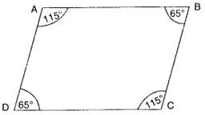 | [2]
26 | Locate$\sqrt{3}$ on the number line. | [3]
27 | Using identity${\left(a+b\right)}^{3}$ = $a^{3}+b^{3}$ + 3ab (a + b) derive the formula $a^{3}+b^{3}$ = (a + b) $\left(a^{2}-ab+b^{2}\right)$ | [3]
28 | Draw the graphs of y = x and y = - x in the same graph. Also find the co - ordinates of the point where the two lines intersect. | [3]
29 | Draw the graph of the following equation. Read a few solutions from the graph and verify the same by actual substitution andfind the points where the line meets the two axes. 2(x + 3)– 3(y + 1) = 0 | [3]
30 | In fig PT is the bisector of$∠$ QPR in $△$ PQR and PS $⊥$ QR, find the value of x  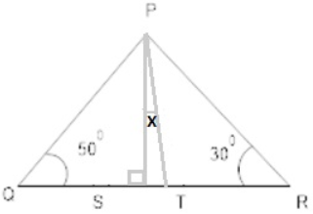 | [3]
31 | From the following figure, prove that$∠$ BAD = 3 $∠$ ADB.  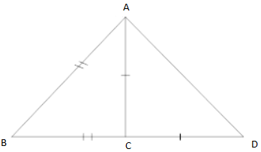 | [3]
32 | Find k so that x$​^{2}$ + 2x + k is a factor of 2x $​^{4}$ + x $​^{3}$ - 14x $​^{2}$ + 5x + 6. Also, find all the zeroes of the two polynomials. | [5]
33 | If the cost of a pen and a pencil be “x” and “y” respectively. A girl pays Rs.16 for buying 2 pens and 3 pencils. Write the given data in the form of a linear equation in two variables. Also represent the same graphically. | [5]
34 | Prove that if the arms of an angle are respectively perpendicular to the arms of another angle, then the angles are either equal or supplementary. | [5]
35 | In a triangle ABC, if AB = AC and AB is produced to D such that BD = BC, find$∠$ ACD : $∠$ ADC. | [5]
36 | Read the following text carefully and answer the questions that follow:  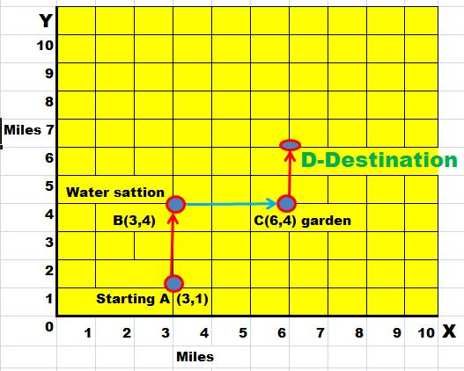  Arun is participating in an 8 miles walk. The organizers used a square coordinate grid to plot the course. The starting point is at A (3, 1).At B (3, 4), there’s a water station to make sure the walkers stay hydrated.  From water station, the walkway turns right and at C (6,4) a garden is situatedto keep walkers fresh. From the garden, the walkway turns left and finally, Arun reaches at destination D to complete 8 miles.  - How far is the water station B from garden C? (1)  - What is the abscissa of destination point D? (1)  - What is the ordinate of destination point D? (2)  - OR  - What are the coordinates of destination point D? (2) | [4]
37 | Read the following text carefully and answer the questions that follow:  Maths teacher draws a straight line AB shown on the blackboard as per the following figure.  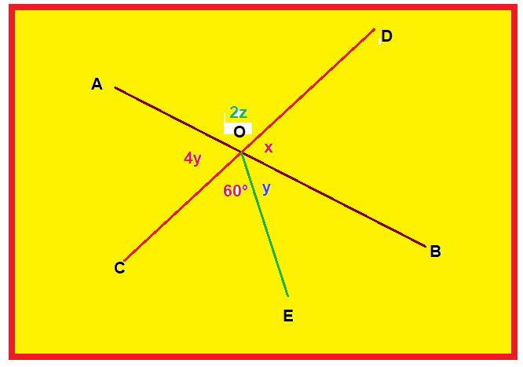  - Now he told Raju to draw another line CD as in the figure  - The teacher told Ajay to mark$∠$ AOD as 2z  - Suraj was told to mark$∠$ AOC as 4y  - Clive Made and angle$∠$ COE = 60°  - Peter marked$∠$ BOE and $∠$ BOD as y and x respectively  Questions:  - What is the value of y? (1)  - What is the value of z? (1)  - What should be the value of x + 2z? (2)  - OR  - What is the relation between y and z? (2) | [4]
38 | Read the following text carefully and answer the questions that follow:  In a forest, a big tree got broken due to heavy rain and wind. Due to this rain the big branches AB and AC with lengths 5m fell down on the ground. Branch AC makesan angle of 30° with the main tree AP. The distance of Point B from P is 4 m. You can observe that $Δ$ ABP is congruent to $Δ$ ACP.  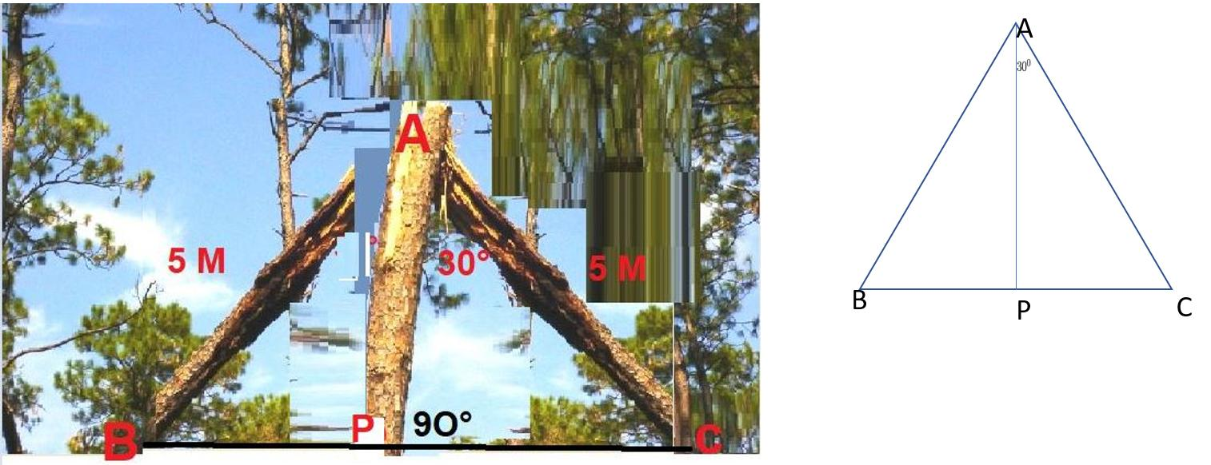  - Show that$△$ ACP and $△$ ABP are congruent. (1)  - Find the value of$∠$ ACP? (1)  - Find the value of$∠$ BAP? (2)  - OR  - What is the total height of the tree? (2) | [4]

***With Best Wishes***


  आपका परिश्रम + हमारा मार्गदर्शन = निश्चित सफलता  



Admission Open for Class 7_12 / NEET / JEE / B.SC / M. Sc/ PAT / ICAR / CET

